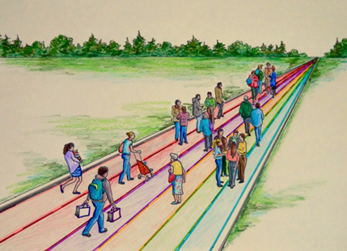

THINKING OTHERWISE:
A CONVERSATION ABOUT EDUCATION
WITH DON GLENDENNING

Education 20/20 Inc.
www,education2020.ca
Tel: 902-892-2060
pei@education2020.ca

DONALD E. M. GLENDENNING, C.M.
President Emeritis
Holland College

Don Glendenning grew up on the banks of the Miramichi in New Brunswick. He began teaching at age 17 in a one-room school and ended up as the Founding President of Holland College in Prince Edward Island, home of the Atlantic Police Academy and the Culinary Institute of Canada. Along the way he was a teacher, principal, Teacher Trainer, and Training Consultant with Department of Labour in Ottawa. He is a graduate of the Miramichi Rural High School, Teachers College, Fredericton, NB and the New Brunswick Institute of Technology, Moncton, NB. He also studied at the University of London (Eng.) and holds degrees from Bradley University in Peoria Illinois and Indiana University. He is president of a new group, Education 20/20 Inc. whose interest is a quality education for every Canadian.

After retirement he formed his own consulting firm with projects in Canada, Africa, Pakistan, China and South East Asia.

His passion is education, which he views as the act helping people learn new attitudes, skills and knowledge in order to thrive on the road of life. He believes in a system more focused on learners and their needs, more flexible and more transparent.

He was also active in a number of professional and community activitities; Don and his wife, Carol, live in Charlottetown, PEI.
4 Don/Broch-2
Pres-1

